O’ZBEKISTON RESPUBLIKASI MUDOFAA VAZIRLIGI HARBIY XAXFSIZLIK VA MUDOFAA UNIVERSITETINING AXBOROT-KOMMUNIKATSIYA TEXNOLOGIYALARI VA HARBIY ALOQA INSITUTI



AXBOROT-KOMMUNIKATSIYA TEXNOLOGIYALARI VA SUN’IY INTELLEKT KAFEDRASI
“Suniy intellekt asoslari” FANIDAN

MUSTAQIL ISH

Bajardi: Bo’ronov D.
Qabul qildi: Isakov .

Toshkent 2025
2-topshiriq
2.1 Ikkilik fileni o’qish va yozish: image.png fileni ikkilik rejimda o’qing, uning birinchi 100 bitni konsolga chiqaring. So’ngra yangi file (Masalan: image_copi.png) nusxalashni amalga oshiring.
2.2 Filega qo’shimcha yozish: log.txt file oching va unga “Yangilangan malumot” matnini qo’shing. File oxirgi yozuvini o’qing va ekranga chiqarib bering.

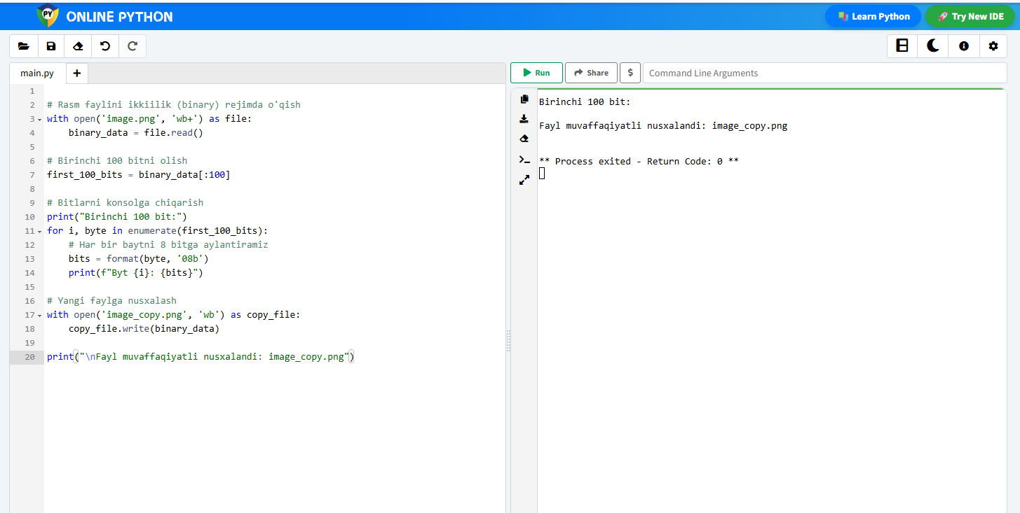

1-rasm: 2.1 masala yrchim
Yechim:
with open(‘image.png’, ‘rb’) as file:
binary_data = file.read()

first_100_bits = binary_data[:100]
print(“Birinchi 100 bit:”)
for i, byte in enumerate(first_100_bits):
bits = format(byte, ‘08b’)
print(f”Byt {i}: {bits}”)

with open(‘image_copy.png’, ‘wb’) as copy_file:
copy_file.write(binary_data)

print(“\nFayl muvaffaqiyatli nusxalandi: image_copy.png”)

2.2 masala
with open('log.txt', 'a', encoding='utf-8') as file:
file.write("Yangilangan malumot\n")
try:
with open('log.txt', 'r', encoding='utf-8') as file:
content = file.read().strip().split('\n')
if content:
last_entry = content[-1]
print("Oxirgi yozuv:", last_entry)
else:
print("Fayl bo'sh")
except FileNotFoundError:
print("log.txt fayli topilmadi. Yangi fayl yaratildi.")

